version：V 1.0
2D barcode scanning platform

二维条码扫描平台 快速设置手册

1. Factory Defaults恢复出厂设置
Note: Scanning the following barcode can restore the engine to the factory defaults. See user's manual for more information.
注意：请谨慎使用“恢复出厂设置”功能，读取此设置码后，将失去当前的参数设置，代以出厂时的默认值。出厂默认的参数和功能可参见《用户手册》。

Restore All Factory Defaults
恢复出厂设置
2. Communication Interface通讯接口
2D barcode scanning platform provides USB interface, USB virtual serial port, TTL-232, RS-232 serial communication interface and USB HID-POS interface to communicate with the host. Through the communication interface, you can receive reading data, and change the 2D bar code scanning platform function parameters.
二维条码扫描平台提供USB接口、USB虚拟串口、TTL-232、RS-232串行通讯接口以及USB HID-POS接口与主机进行通讯。经由通讯接口，可以接收识读数据，以及更改二维条码扫描平台的功能参数等。

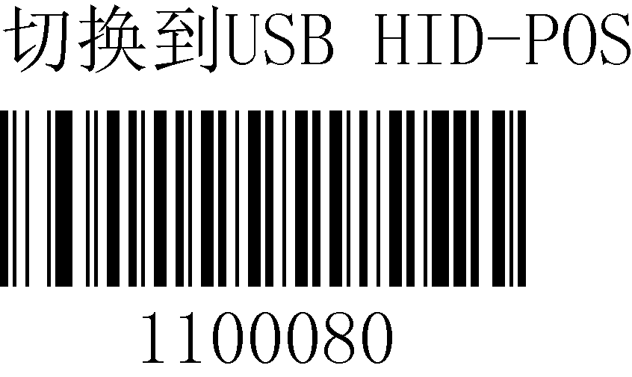
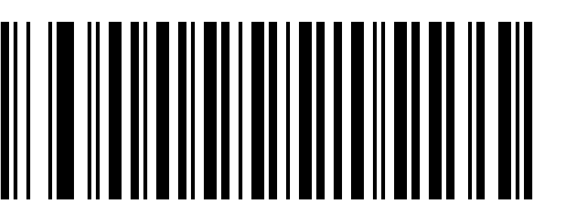

**USB HID-KBW USB HID-POS
切换到 USB 接口 切换到USB HID-POS
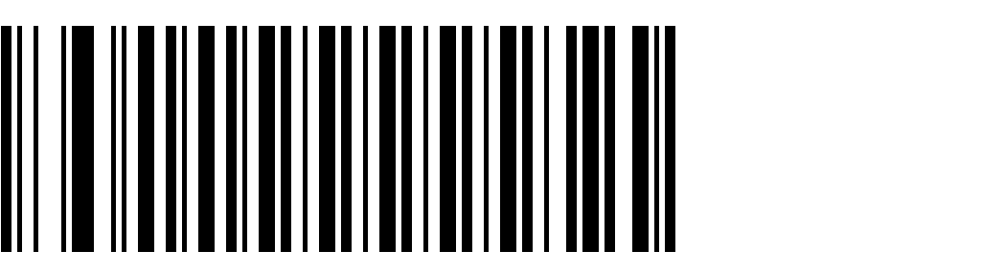
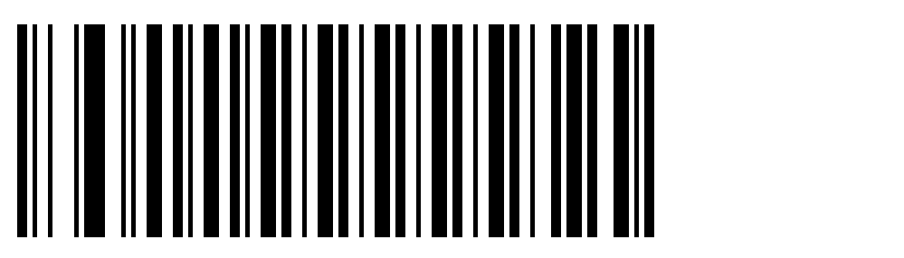

TTL-232 Serial Communication RS-232 Serial Communication
切换到TTL-232串行通讯 切换到RS-232串行通讯

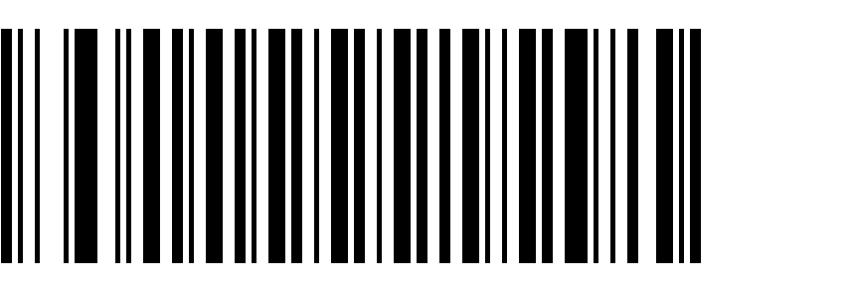

USB virtual serial port
切换到USB虚拟串口
3. USB Country Keyboard Types国家/语言键盘布局选择
Keyboard layouts vary from country to country. which can be based on the need of the keyboard in different countries.
不同国家语言对应的键盘键位排布，符号等不尽相同。可以根据需要虚拟成不同国家的键盘制式。

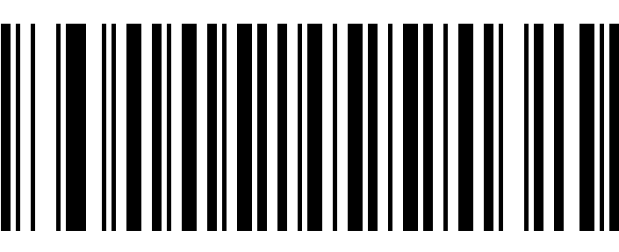
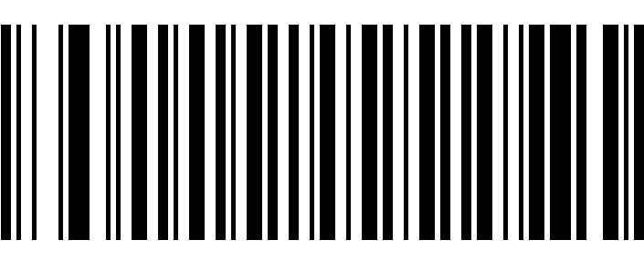
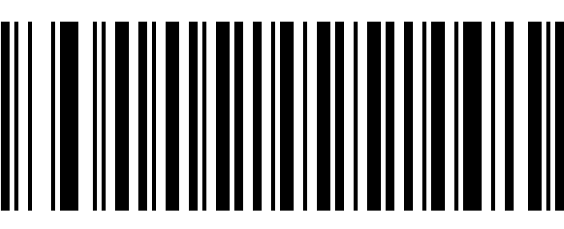
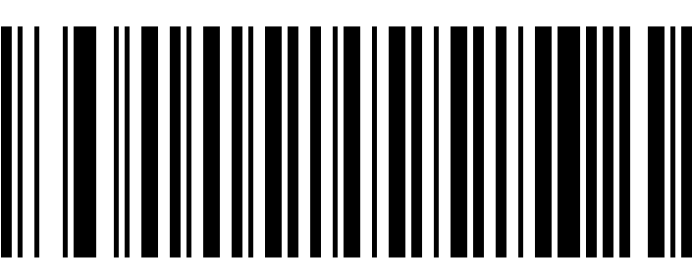
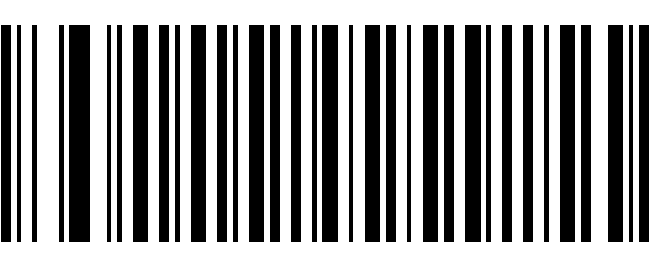

**U.S. Global Language全球通用

Denmark Finland

France Turkey_F

Italy Norway

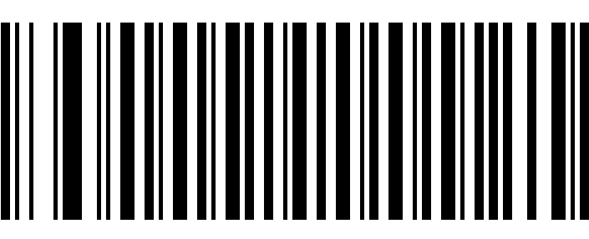

Spain Turkey_Q

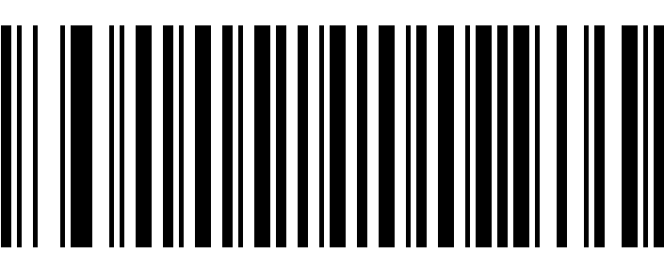

UK

Belgium Portugal

Sweden Austria,Germany

4.Set Terminating Character Suffix修改结束符
The engine provides a shortcut for setting the terminating character suffix to CR (0x0D) , CRLF (0x0D,0x0A) or HT(0x09) and enabling it by scanning the appropriate barcode below.
读取以下设置码，可以快速将结束符设定为回车(0x0D)，回车+换行(0x0D+0x0A)或TAB键（0x09）。

** Terminating Character CR (0x0D) Terminating Character CRLF (0x0D,0x0A)
设定添加结束符为回车(0x0D) 设定添加结束符为回车+换行(0x0D+0x0A)

+

Terminating Character HT (0x09)
设定添加结束符为TAB键(0x09)

5.Beep Notifications声音设置
Startup Beep开启/关闭声音

** Enable Startup Beep Disable Startup Beep
**开启声音 关闭声音

Beep Type声音类型
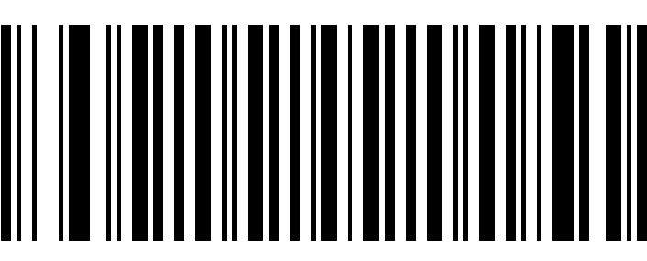
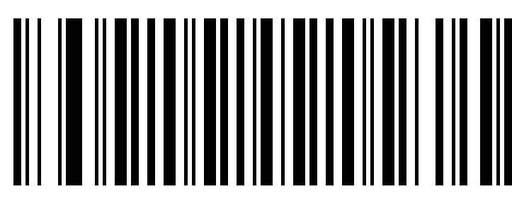

Type 1 Type 2
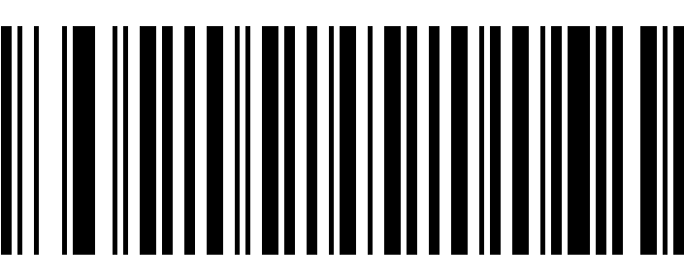

** Type 3

Beep Volume声音大小

**Loud Medium

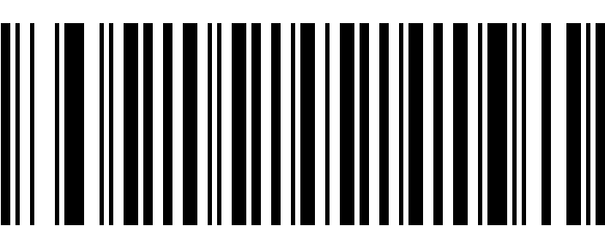

Low

